JIM DUNN

**CHIEF EXECUTIVE OFFICER**

**CHIEF INVESTMENT OFFICER**

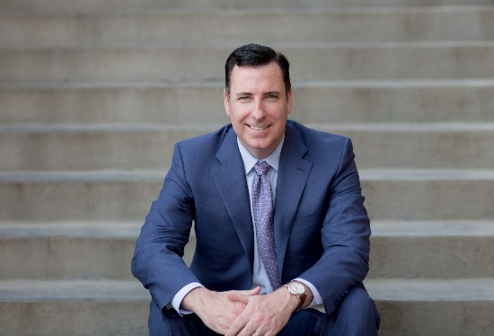

As Verger’s Chief Executive and Chief Investment Officer, Jim oversees all investment decisions and is responsible for setting the course for the company, leading our corporate strategy and ensuring that Verger remains competitively positioned to serve our partners’ needs in an increasingly complex and volatile market environment.

Previously, Jim was Vice-President and Chief Investment Officer at Wake Forest University, responsible for investment of the University's endowment, working capital and life income assets. Prior to joining Wake Forest, Jim served as Managing Director at Wilshire Associates Inc., and Chief Investment Officer and Portfolio Manager for Wilshire Funds Management, the money management arm of Wilshire Associates. At Wilshire, Jim was responsible for providing leadership on asset allocation, investment policy and investment manager selection. Jim served as the Chairman of the Wilshire Funds Management Investment Committee and served as Portfolio Manager for all of Wilshire Fund Management’s alternative investment portfolios.

Jim holds a BBA in finance from Villanova University, where he was a member of the NCAA Division I men’s varsity soccer team. He currently serves as a member of the Institutional Investor Endowments and Foundations Advisory Board and as the Treasurer of the James Denmark Loan Fund. Jim also sits on the SEI Canada Independent Review Committee as an Independent Director and the Villanova University’s President’s Advisory Council.

**ABOUT VERGER CAPITAL MANAGEMENT**

Verger Capital Management (Verger) is an SEC registered investment adviser providing Outsourced Chief Investment Officer (OCIO) services to a select group of non-profit institutions. Verger’s mission is to *invest in the lives of others,* which has lead the firm to exclusively serve clients focused on improving lives and providing opportunity. The Verger team’s unique non-profit heritage offers a deep understanding of this segment’s needs, as well as the ability to benefit from the scale and purchasing power of approximately $1.8 billion in assets under management.

To learn more, visit [www.vergercapital.com](http://www.vergercapital.com).